## Example: Are Men Getting Faster?

The following data set (mensm.txt) contains the winning times (in seconds) of the 22 men’s 200 meter Olympic sprints held between 1900 and 1996. (Notice that the Olympics were not held during the World War I and II years.) Is there a linear relationship between year and the winning times? The plot of the estimated regression line sure makes it look so!

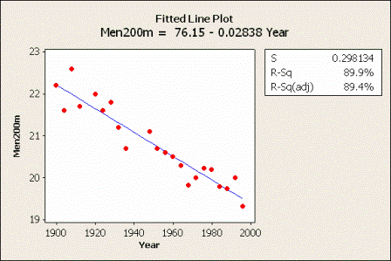

To answer the research question, let’s conduct the formal $F$-test of the null hypothesis $H_{0}:β_{1}=0$ against the alternative hypothesis $H_{A}:β_{1}≠0$.

|  |  |  |
| --- | --- | --- |
|  |  |  |
|  |  |  |

The analysis of variance table, which was obtained in Minitab, and can be seen in the above matrix. As a reminder, the methods for calculations is presented.

From a scientific point of view, what we ultimately care about is the $P$-value, which Minitab indicates is 0.000 (to three decimal places). That is, the $P$-value is less than 0.001. The $P$-value is very small. It is unlikely that we would have obtained such a large $F^{*}$ statistic if the null hypothesis were true. Therefore, we reject the null hypothesis $H_{0}:β_{1}=0$ in favor of the alternative hypothesis $H_{A}:β_{1}≠0$. There is sufficient evidence at the $α=0.05$ level to conclude that there is a linear relationship between year and winning time.

Equivalence of the analysis of variance $F$-test and the $t$-test

As we noted in the first two examples, the $P$-value associated with the $t$-test is the same as the $P$-value associated with the analysis of variance $F$-test. This will always be true for the simple linear regression model. It is illustrated in the year and wining time example also. Both $P$-values are 0.000 (to three decimal places):

The $P$-values are the same because of a well-known relationship between a $t$ random variable and an $F$ random variable that has 1 numerator degree of freedom. Namely:

$${\left(t_{\left(n-2\right)}^{*}\right)}^{2}=F_{\left(1,n-2\right)}^{*}$$

This will always hold for the simple linear regression model. This relationship is demonstrated in this example as:

$${\left(-13.33\right)}^{2}=177.7$$

In short:

* For a given significance level $α$, the $F$-test of $β_{1}=0$ versus $β_{1}≠0$ is algebraically equivalent to the two-tailed $t$-test.
* We will get exactly the same $P$-values, so…
  + If one test rejects $H_{0}$, then so will the other.
  + If one test does not reject $H_{0}$, then so will the other.

The natural question then is … when should we use the $F$-test and when should we use the $t$-test?

* The $F$-test is only appropriate for testing that the slope differs from 0 $\left(β_{1}≠0\right)$.
* Use the $t$-test to test that the slope is positive $\left(β_{1}>0\right)$ or negative $\left(β_{1}<0\right)$. Remember, though, that you will have to divide the $P$-value that Minitab reports by 2 to get the appropriate $P$-value.

The $F$-test is more useful for the multiple regression model when we want to test that more than one slope parameter is 0. We’ll learn more about this later in the course!

Quick reference: $α$, $r^{2}$, $β_{1}$ $H_{0}:β_{1}=0$